**SCENARIO**

You are an electrical technician in a company producing various electronic printed circuits for domestic applicant (TV, Radio, Heaters…etc.) as attenuators, amplifier, tuners…etc., you are required to apply two port network models and use your knowledge about signal analysis including composite signals and the calculation of the circuit response in case of step input.

**To achieve the assessment criteria for pass (P2.1) you must answer the following task**

**Task 1:**

A coaxial cable connects between a signal generator (having internal resistance of **250 Ω**) and a receiver with equivalent resistance of (**250 Ω as a load**). If the coaxial cable can be modeled by symmetrical T attenuator (as shown in figure 1) and R1 is R $Ω$ (as shown in table 1) and R2 is 250 $Ω$. **Apply two port model to:**

1. **Find**:
   1. Characteristics impedance **Zo**.
   2. Attenuation in **dB**.
2. **Solve the following practical problems:**
   1. The signal does not received at the receiver end and the input impedance is measured to be as shown in table (1_Row 3 **{your assessor will choose certain column for you}**). **Estimate what is the problem (Justify your estimation) and your proposed solution**.
   2. The signal does not received at the receiver end and the input impedance is measured to be as shown in table (1_Row 4**{your assessor will choose certain column for you}**). **Estimate what is the problem (Justify your estimation) and your proposed solution.**

**250Ω load**

**250Ω**

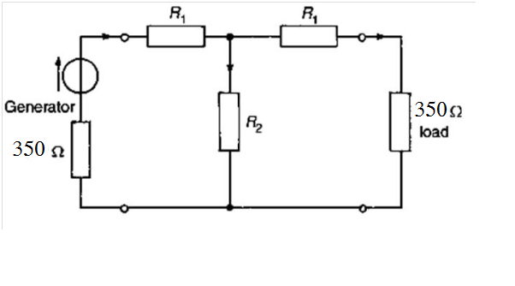

**Figure (1)**

|  |  |  |  |  |  |  |  |  |
| --- | --- | --- | --- | --- | --- | --- | --- | --- |
| **R1 Ω** | **100** | **200** | **300** | **400** | **500** | **600** | **700** | **800** |
| **Zin(b_1) Ω** | **171.42857** | **311.1** | **436.4** | **553.8** | **666.7** | **776.5** | **884.2** | **990.5** |
| **Zin(b_2) Ω** | **350** | **450** | **550** | **650** | **750** | **850** | **950** | **1050** |

**Table (1)**

**To achieve the assessment criteria for pass (P2.2) you must answer the following task**

**Task 2:**

1. Design a **T-section** (Figure 2) symmetrical attenuator to provide a **voltage attenuation of X dB** having a characteristic impedance of **Zo**.

* Select values of X and Zo from **table (2) {your assessor will choose certain column for you}** according to your group.
* Prove your answer by simulation using your software package.
  + Put 10 V DC as an input Source.
  + Put Load = Zo as given in the table below.

|  |  |  |  |  |  |  |  |  |
| --- | --- | --- | --- | --- | --- | --- | --- | --- |
| **X in dB** | **10** | **11** | **12** | **13** | **14** | **15** | **16** | **17** |
| **Zo Ω** | **100** | **100** | **100** | **100** | **100** | **100** | **100** | **100** |

Table (2)

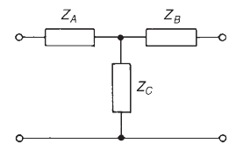

Figure (2)

1. Design a $π$**-section** (Figure 3) symmetrical attenuator to provide a **voltage attenuation of X dB** having a characteristic impedance of **Zo**.

* Select values of X and Zo from **table (3) {your assessor will choose certain column for you}** according to your group.
* Prove your answer by simulation using your software package.
  + Put 10 V DC as an input Source.
  + Put Load = Zo as given in the table below.

|  |  |  |  |  |  |  |  |  |
| --- | --- | --- | --- | --- | --- | --- | --- | --- |
| **X in dB** | **10** | **11** | **12** | **13** | **14** | **15** | **16** | **17** |
| **Zo Ω** | **100** | **100** | **100** | **100** | **100** | **100** | **100** | **100** |

Table (3)

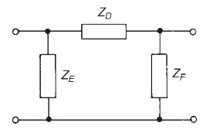

Figure (3)

**To achieve the assessment criteria for pass (P3.2) (Part 2/2) you must answer the following task**

**Task 3:**

Use your software simulator to analyze complex waves as input from a function generator and passes through coaxial cable modeled as T model as shown in figure (4):

**Use input wave:**

* Triangle wave.
* Square wave.

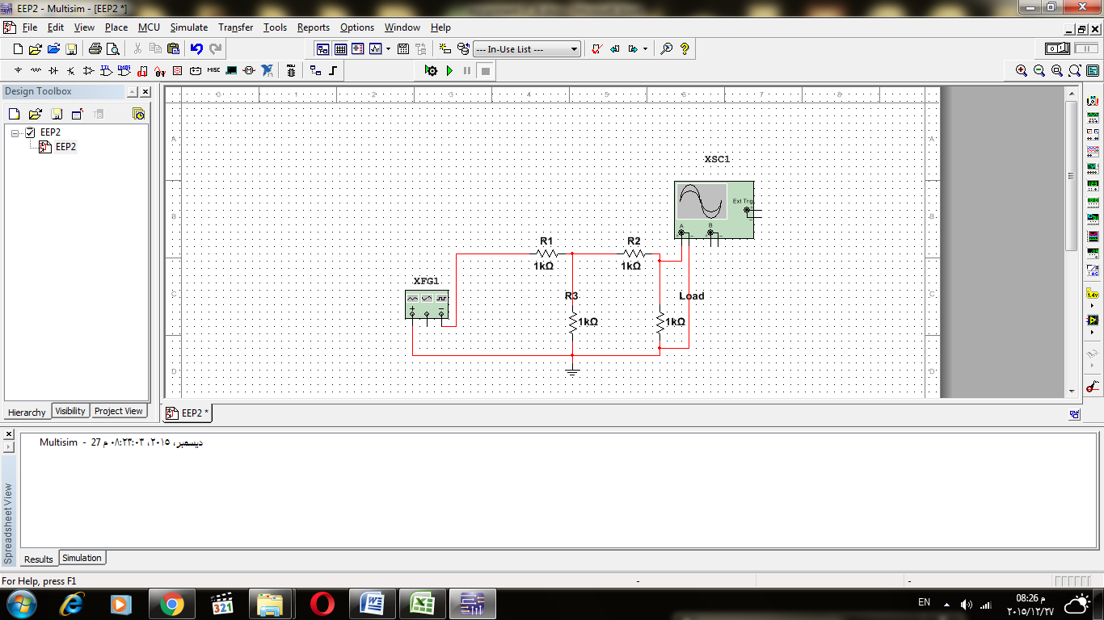

Figure (4)

**Note:**

* Analyze: Find the first 3 harmonic amplitudes.
* Use the frequencies and peak amplitudes as shown in table (4) **{your assessor will choose certain column for you}**.

|  |  |  |  |  |  |  |  |  |
| --- | --- | --- | --- | --- | --- | --- | --- | --- |
| **Frequency kHz** | **1 kHz** | **2 kHz** | **3 kHz** | **4 kHz** | **5 kHz** | **6 kHz** | **7 kHz** | **8 kHz** |
| **Peak Amplitude** | **10 Volts** | **10 Volts** | **10 Volts** | **10 Volts** | **10 Volts** | **10 Volts** | **10 Volts** | **10 Volts** |

Table (4)

**To achieve the assessment criteria for pass (P4.1) you must answer the following tasks**

**Task 4:**

Use Laplace transforms for the transient analysis of the networks shown in figure (5)

**Note:**

* Transient analysis (find i(t) , Vc(t)) for figure (5-a)
* Transient analysis (find i(t) , VL(t)) for figure (5-b)
* You can use the Laplace Transform table (5).

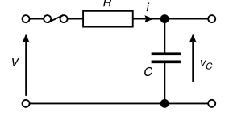

Figure (5-a)

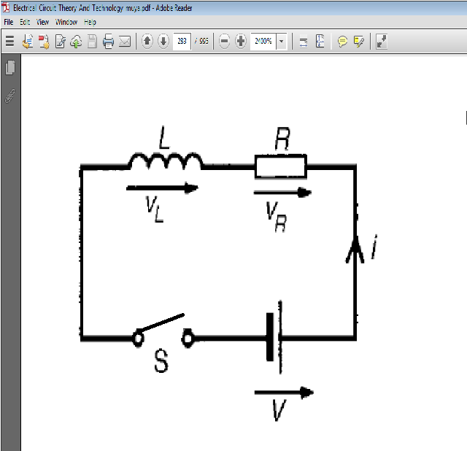

Figure (5-b)

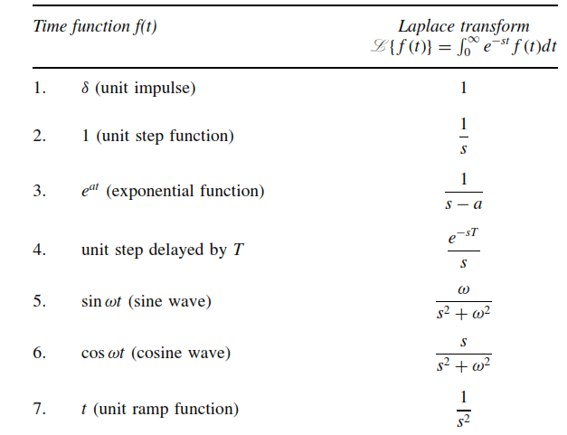

Table (5)

**For figure (5-a)If C=100µF, R= as in table (6) {your assessor will choose certain column for you} and *V*=10V answer the following:**

Calculate the Voltage at the capacitor after time T as shown in table (7) from closing the switch in figure (5_a) Record your results in table (7).

|  |  |  |  |  |  |  |  |  |
| --- | --- | --- | --- | --- | --- | --- | --- | --- |
| **R in (Ω)** | **100** | **200** | **300** | **400** | **500** | **600** | **700** | **800** |

Table (6)

|  |  |  |  |  |  |
| --- | --- | --- | --- | --- | --- |
| $$5RC$$ | $$4RC$$ | $$3RC$$ | $$2RC$$ | ***RC*** | **Time** |
|  |  |  |  |  | **The Voltage** |

Table (7)

**To achieve the assessment criteria for pass (P4.2) you must answer the following task**

**Task 5:**

A DC motor with armature winding with (L mH inductance) is connected to a DC source with (Vs= 30 Volts and internal resistance R Ω) via long cable with stray capacitance of (C µF) the behavior of the motor differs each time the switch "S" closed if {different motor (different L) or DC supply type (different internal resistance R) or different Cable length (different C)} are used.

**Apply circuit response to calculate the transient current (current as a function of time, iL(t), for all t) and the damping case in only the two cases assigned to you from the following cases {your assessor will choose certain column for you}:**

**A) R= 0 Ω, L=150mH and C=1μF**

**B) R=200Ω, L=20mH and C=1μF**

**C) R=300Ω, L=100mH and C=1μF**

**D) R=400Ω, L=200mH and C=1μF**

**E) R=0 Ω, L=30mH and C=1μF**

**F) R=500Ω, L=50mH and C=1μF**

**G) R=600Ω, L=10mH and C=1μF**

**H) R=700Ω, L=300mH and C=1μF**

**Given that: iL(t = 0 ) = 0 A and step voltage of VS = 30 V.**



**Figure (6)**

**To achieve the assessment criteria for pass (M3.1 and D3.4) you must answer the following task**

**Task 6:**

**Read the following problems:**

1. A coaxial cable connected between transmitter and receiver. The cable is modeled by a symmetrical π model. The data sheet of the cable gives (R1 Ω and R2 Ω as in table (8)) for each section of length 10 m. The distance is 100 m between the Transmitter and the receiver. The actual signal received is very weak.
2. An internet coaxial cable seems to be malfunction **(no signal received at the second end)**. The cable can be modeled as symmetrical T model. The data sheet of the cable gives (R1= 15 Ω and R2 = 15 Ω). We have the following measurements (Zin = 22.5 Ω , signal speed inside the cable = 2.1x108 m/sec, reflected signal after time = t µ sec as in table (9)).

|  |  |  |  |  |  |  |  |  |
| --- | --- | --- | --- | --- | --- | --- | --- | --- |
| **R1** | **10** | **10** | **10** | **10** | **20** | **20** | **20** | **20** |
| **R2** | **10** | **15** | **20** | **25** | **25** | **30** | **35** | **40** |

Table (8)

|  |  |  |  |  |  |  |  |  |
| --- | --- | --- | --- | --- | --- | --- | --- | --- |
| **t** µ sec | **10** | **20** | **30** | **40** | **50** | **60** | **70** | **80** |

Table (9)

**For each problem:**

* + Define the problem.
  + Justify your problem definition. **(M3.1)**
  + State your proposed solution or solutions. **(D3.4)**

**To achieve the assessment criteria for pass (D2.2) you must answer the following task**

**Task 7:**

Implement the T and $π$ attenuators you have designed before in **Task (2)** specify each of the following:

* Resources needed.
* Testing the implemented model.